Year to Date Budget Report

Objective
This document provides instructions for generating a Year-to-Date Budget report. The Year-to-Date (YTD) Budget report serves as a primary monthly budget report, but its flexible definition makes it suitable for special analysis purposes.

Procedure
To create a year-to-date budget report:

- Departmental Functions > YTD Budget Report
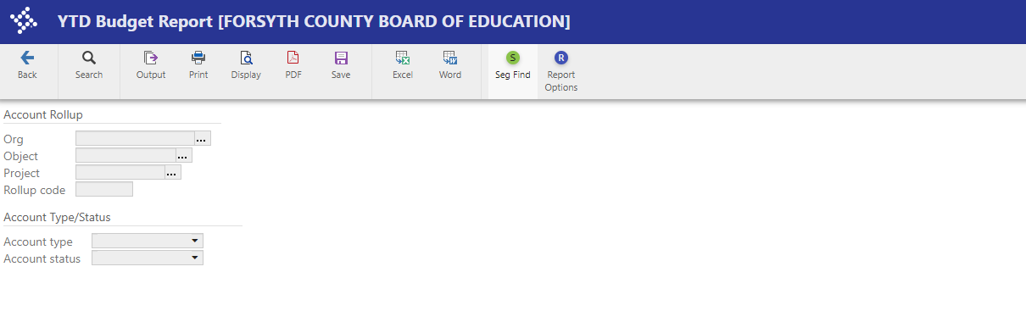
Click Search  on the ribbon to identify accounts for the YTD Budget Report. Your curser will be flashing in the org box. (Note that you can optionally select Segment Find from the Advanced Search, but that method is not covered in this tutorial.)
Elementary
XX101011..XX221310
Middle
XX101081..XX221310
High
XX101041..XX221310

Enter your Org range and hit TAB.
You may also enter a single Org.

You can now leave the object blank and it will give you a complete budget report including staff development.

OR Enter object 530000..589000 This will pull all object codes you have access to spend from. You may also enter a single object number.
Click Accept  on the ribbon.

For either search method, the program displays the number of records found.
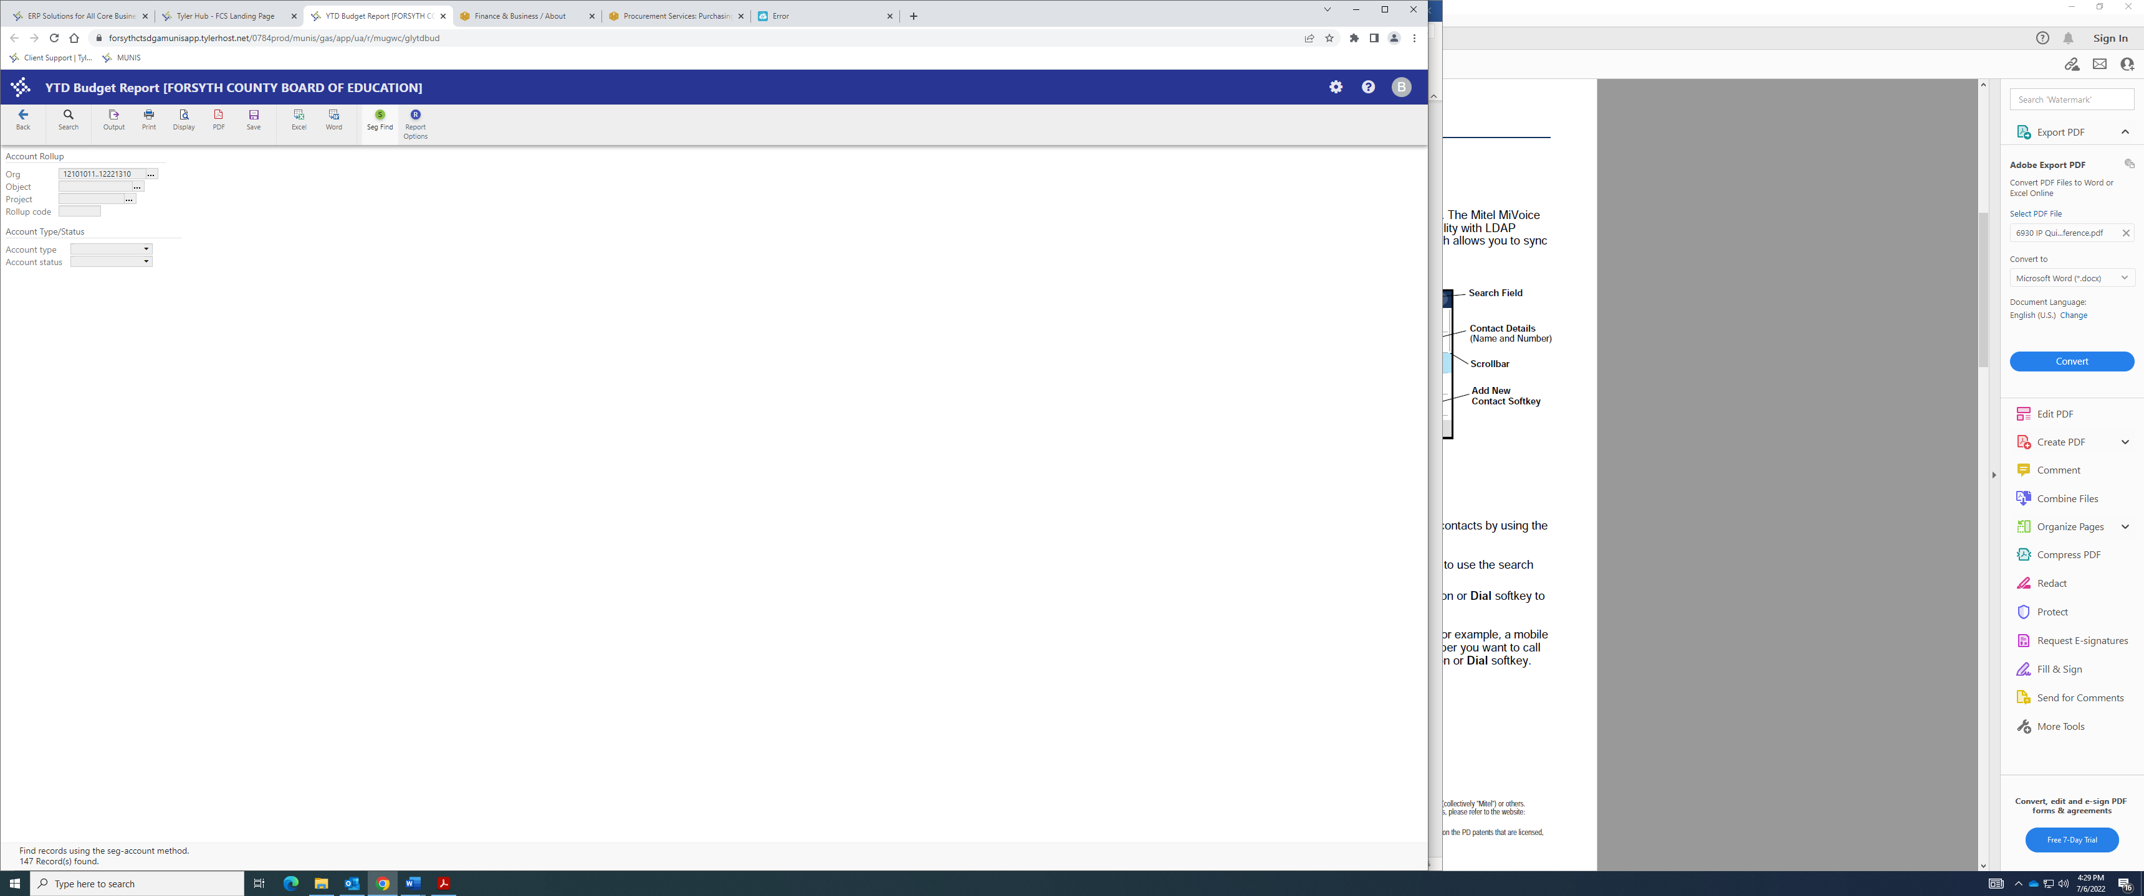

Click Report Options to specify how you would like the results displayed.

The program displays the Report Options screen. Make your screen look like the screen below:
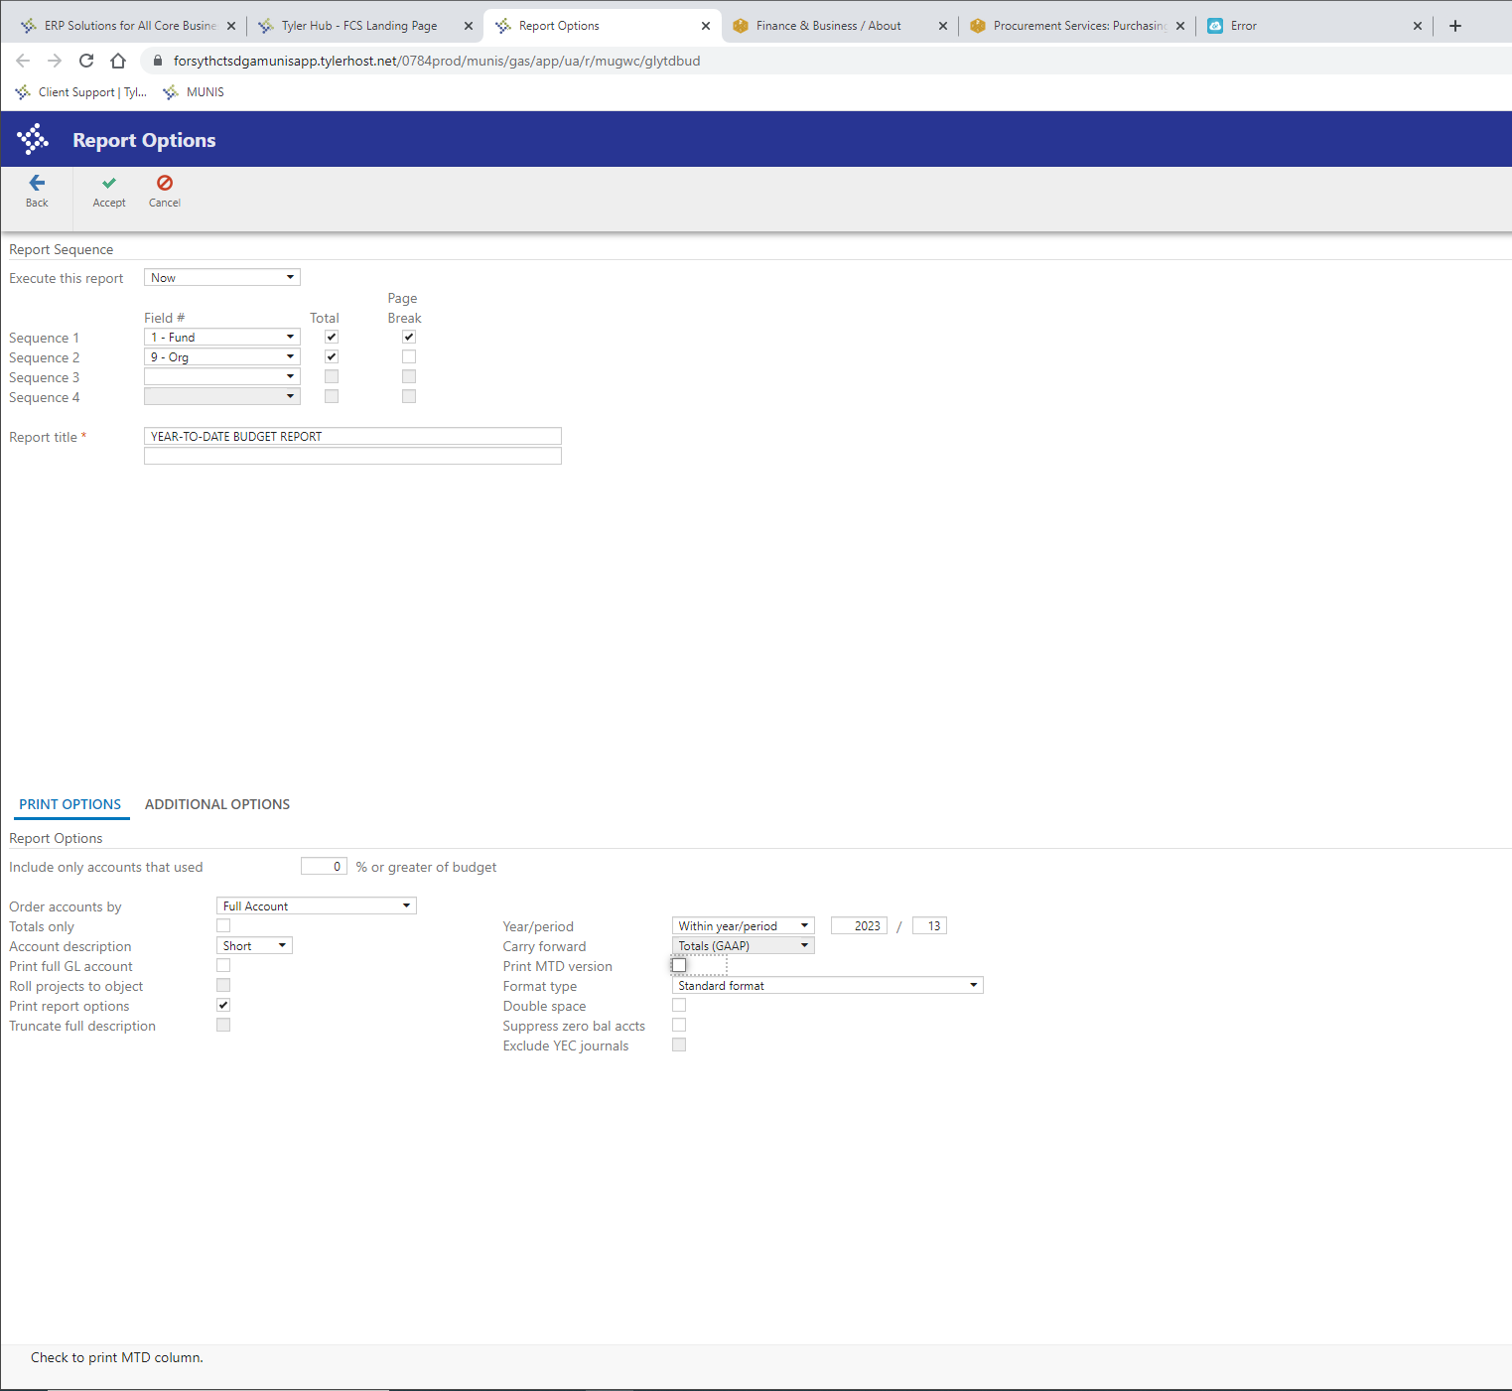

Additional Options Tab

Your screen should look like this:
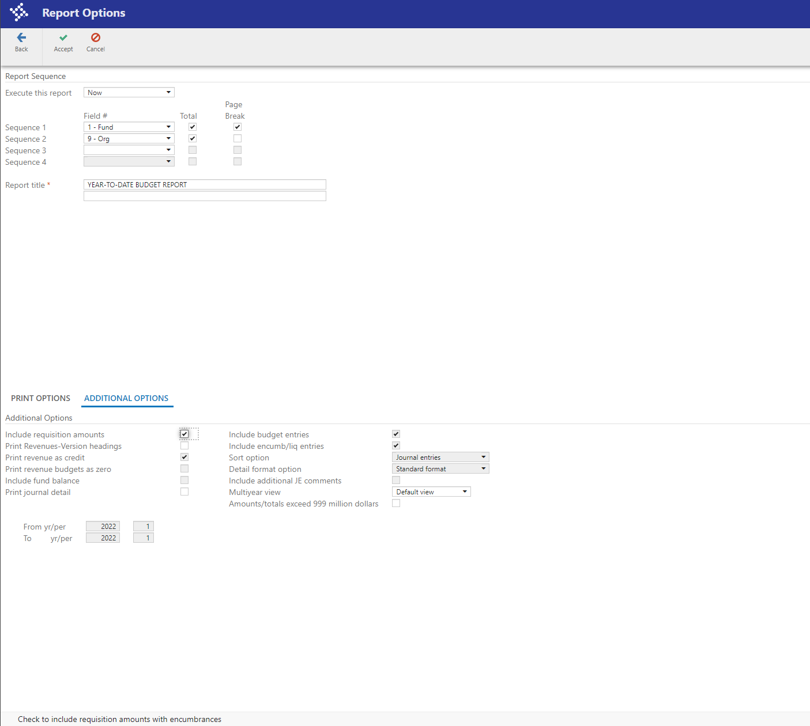

You have the option of including requisition amounts and journal detail.

Click Accept .
Click the Back  to close the Report Options screen.

On the main screen, click Display 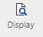 to display your report, Print 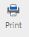 to print the report or either 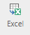 or  to download report data to these programs.

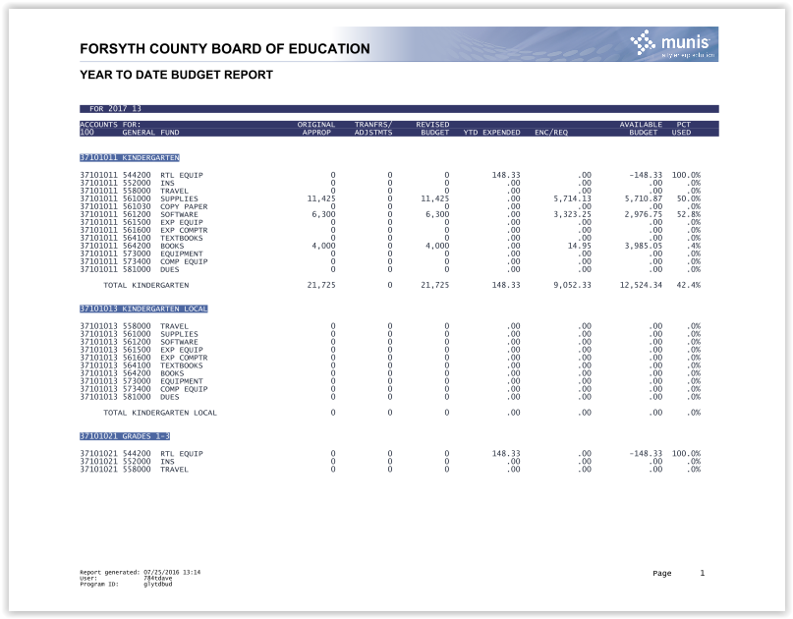
Your report displays according to the report options that you selected.

Results
You can now analyze what transactions have occurred within your search and sequence settings, confirm that a budget was posted correctly, proof your chart of accounts, or look at transactions for a specific period.

